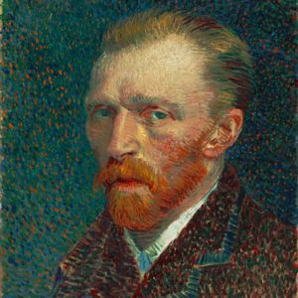
Y5R
Mr Reader
Van Gogh Class
Autumn Term 1 - Information Guide
1st Half Term 2016
Our learning this term
Our topic is ‘Peasants, Princes and Pestilence’

English - We will be examining persuasive vocabulary to help progress our writing and speech. As such, we will be creating journals to showcase our mastery of the topic. This will culminate in a short performance play, we hope, at Curium amphitheatre.
Maths – We will begin the year by focusing on calculation including place value, addition, subtraction, multiplication and division.
Science - As part of our study into the plague, our science topic will cover rodents, fleas and bacteria.
Other subjects – In history, we will delve into a Britain impacted by Black Death, Wat Tyler, the Peasants’ Revolt and the role of King Richard II. This will, in turn, feed into map making in Geography, plague mask making in DT and use of charcoals in Art and Design.

Computing –

VISITS AND ENRICHMENT
This half term, through the power of interactive media, we will be visited by the personification of ‘Pestilence’ as we open up our exploration of a dark, yet captivating, 14th Century Britain. We plan to ‘meet’ rats, insects and bacteria with a visit from Environmental Health and finish with a visit to Curium amphitheatre to deliver a mini-performance of aspects of this topic. (More details to follow.)
SPELLING: In the first week we have sought to gather a spelling ability baseline by asking children to revisit prior year spellings in class. A new spelling scheme is to be introduced (information to follow) and children will be given age / ability appropriate spellings to practice, with your support, at home.

MENTAL MATHS FOCUS
Revising number bonds to 50, 100, 1000
Revising strategies to add and subtract mentally
Ensure knowledge of tables is secure for 3x, 4x, 5x, 6x, 7x as a minimum requirement.
READING (Reading records will be issued shortly)
Autumn 1 – It is important that your child’s reading book and reading record comes into school every day. They will work with an adult to improve their reading skills at least once a week through guided reading sessions and in other lessons.
Our novel for this half term is ‘There’s a Girl in the Boys’ Bathroom’ by Louis Sachar.
HOW TO HELP YOUR CHILD
Please support your child with their homework and encourage them to aim high and produce neat work of a good standard. Please also read with / listen to your child reading regularly (at least 1 hour a week) and comment and sign in the reading diary. Remember to question them about what they have read and make it a pleasurable experience.
HOMEWORK: A homework book and information sheet will be sent out half-termly with varying levels of challenge. Homework books will be sent home on a Friday and should be brought into school on a weekly basis when completed. (More details can be found on the homework sheet)

USEFUL INFORMATION
PE: Monday & Thursday
Swimming: TBC Year 5 children are likely to swim after the October half term.

