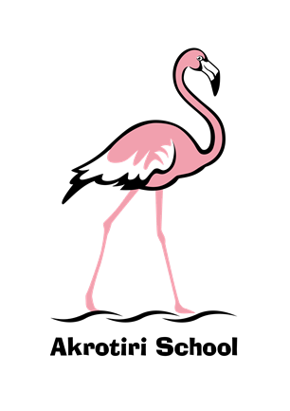

*Please note that in the future the ‘Friday Feeling’ will be emailed out. The first was sent out via email last week, but I am aware this did not reach all parents. If you did not receive it please contact the school to update your email – or check the ‘junk’ box. A copy of last week’s is copied on the rear of this ‘Friday Feeling’.*

Friday 13 September 2019

Commencing the day on Friday 13th always gives a sense of doom. But today I am delighted to be leading my first ‘Golden Mention’ assembly at Akrotiri; who will be the deserving recipients?



**Your text here**

**Your text here**

As I continue to get used to the different rhythm of the day in Cyprus, the week has flown by again. I continue to get to know children and staff and have been able to get into classrooms to explore the learning that is taking place. Conversations have been centred around core values and educational principles which I anticipate will feed into policy and practice going forwards.

Meeting the Parent Teacher Association chair, Sarah Bell, earlier this week has introduced me to another great strength of the school and further indication of the incredible community that we have in Akrotiri. I am very excited about the events that are planned over the coming year – and have been able to put forward further ideas to help us work together for the benefit of our children. Exciting times; watch this space!

Finally, thank you to all of the children, staff and parents that I have met and made me feel so welcome this week. I am genuinely excited to be Head of Akrotiri School and look forward to a very bright future with you all.

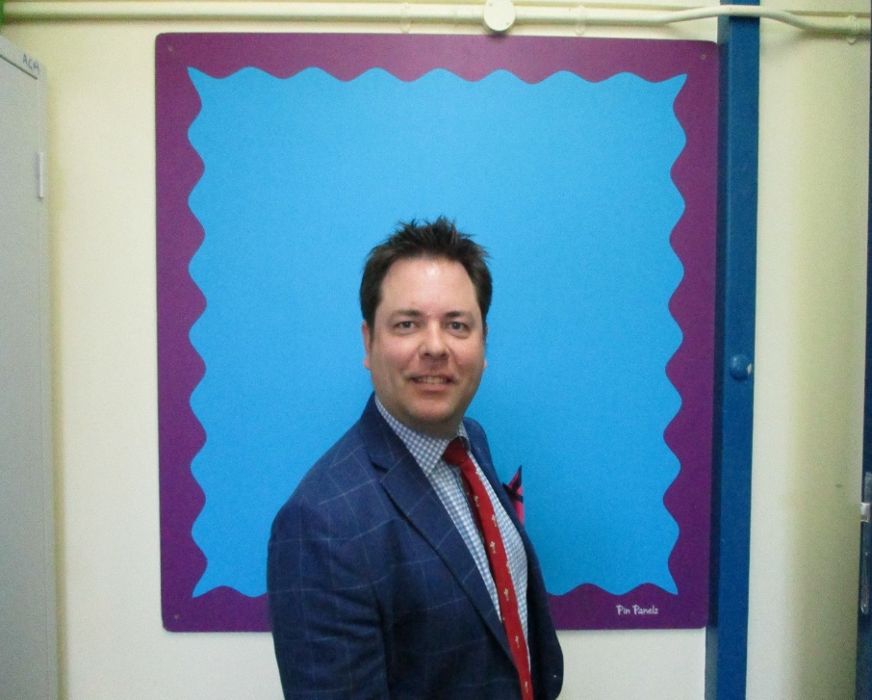

Have a wonderful weekend.

Ben Turner

Headmaster