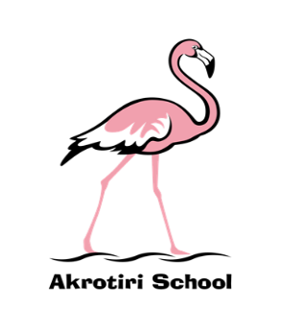
Akrotiri School
Friday Feeling

Friday 20 September 2019
This week started with an assembly about teams. We looked at and discussed how each and every one of us is a crucial part in our Akrotiri School Team – and that how well we play our part impacts upon the whole team. We agreed that we all rely on each other to collectively be the best we can be.
Lieutenant General (retd) Sir Andrew Gregory KBE CB built upon this theme when he visited us on Tuesday. As the current controller of SSAFA, he gave us an inspirational overview of the charity and what it does for service families. I have already had visits from many enthusiastic children proposing fund-raising events to help support the great work of SSAFA. We were privileged to have had Sir Andrew visit the school and thank him very much for making the time in his busy schedule.
Searching for evidence of turtles, Y2 had a very egg’citing visit to Button Bay. They learned about and discovered first-hand the evidence that turtles had hatched and made it to the sea. Unfortunately, some of the eggs hadn’t hatched, but children were fascinated to see the reality of life close up. In this unique setting I’m delighted that staff, children and volunteers have taken advantage of exploring the nature around us.
KS2 have also taken advantage of the opportunities around us to see the Queen’s Colour Squadron drill outside the church yesterday. The children were mesmerised as they observed on point marching, weapon manoeuvres and then very engaging conversations afterwards. A privilege and an honour – thank you!

Have a wonderful weekend.

Ben Turner
Headmaster

