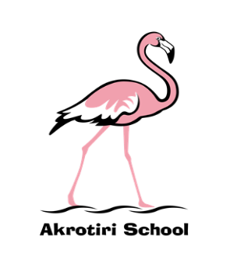
Akrotiri School
Friday Feeling

Friday 27 September 2019
Already onto FF#4, it seems like two minutes since I arrived. There continues to be a drive towards gathering and processing further information about the school and I have been delighted to have the opportuntiy to engage with more parents during the week. I have had some valuable feedback which has helped to feed back into our overall priorities which will be shared with the School Governance Committee (SGC) and wider community shortly. We published details of a SGC recruitment drive this week, so if you are interested in helping to support and challenge our amibitious school please come along next Friday.
A number of our teachers and support staff have been able to take advantage of a couple of training events this week across the island. Firstly, Numicon training (a teaching resource designed to help children visualise numbers. From this visual picture they can see how we can add, subtract, multiply and divide numbers and the relationships between these), and secondly paediatric first aid training. The outcomes of these will be disseminated across the school.
Today I took the opportunity (and liberty!), to add to our weekly ‘Golden Mentions’. I was delighted to be able to invite the recipients to my office for juice and biscuits, and further congratulate them, ‘cheers!’ them, and also find out their thoughts about school. I certainly enjoyed the opportunity and it seemed to go down well with the children too! I have committed to meeting up with the previous winners from this academic year over the course of the next couple weeks.
As the Rugby World Cup is into full swing, I hope you are able to escape or enjoy as appropriate; I intend to catch up and indulge, particularly on Sunday at 10:45. Pob lwc i Gymru!

Have a wonderful weekend.
Ben Turner
Headmaster

