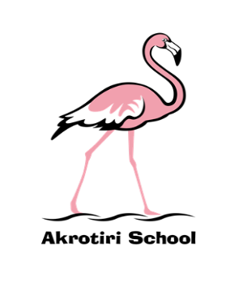
Akrotiri School
Friday Feeling #5

Friday 4 October 2019
The week started with the tremendous RAF Youth STEM team workging with our Y5 and Y6 children. Children were able to design and program robots to race over a short distance, turn around using sensors and return to the start position. The STEM Ambassadors based on Akrotiri were key to the day and we look forward to engaging with them on a wider scale and more regularly over the course of the year and beyond.
I have been really pleased with the feedback I have received in terms of attendance numbers at the year group parent meetings. I hope you have been able to gain a good overview of the curriculum and planned learning and have taken advantage of the opportunity to ask questions. Any feedback is gratefully received.
On a similar theme, the SGC briefing was well attended this morning and I am really encouraged by the number of interested individuals who have come forward to support the school at this very exciting time. The first governor meeting is scheduled for 11 October and I look forward to working in greater depth with our SGC for the benefit of our children and school. We have the capacity and potential to be incredible!
Finally, congratulations to Archie, Millie, Darcey and James from Y6 who represented MoD Schools in a recent swimming gala at St John’s School. We were all delighted with their performances and how well they represented the school in terms of sportsmanship and attitude. Coming back with a huge trophy for their success was the icing on the cake! #winners
Have a wonderful weekend.

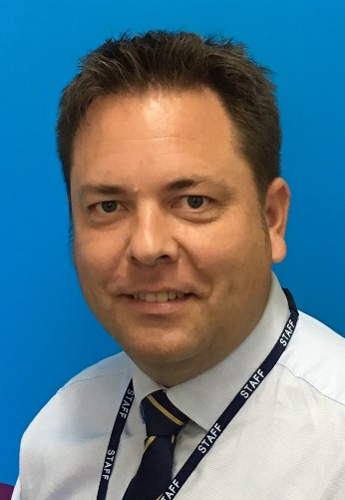
Ben Turner
Headmaster

