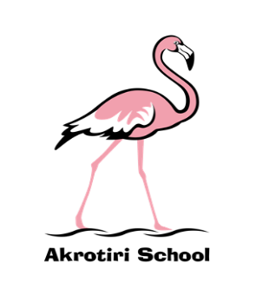
Akrotiri School
Friday Feeling #6
Friday 11 October 2019
Budding authors in Y6 were further invested in their amibitions when Matt Dickinson ran a masterclass in writing earlier in the week. Matt, who has a fascinating backgound in adventure, including climbs of Everest and crossing the South Pole, commented on the extremely high standard of our Y6 writers. He said it was amongst the best that he has seen. Well done Y6!
There was a familiar face with unfamiliar friends on the playground on Wednesday. Mrs Critchley brought along some resuscitation dummies to promote the ‘restart a heart’ campaign. Children flocked to learn vital life saving skills and as always Mrs Critchley, now our school nurse, delivered the training with great enthusiasm and passion. I think the soundtrack of ‘Stayin’ Alive’ helped!
Two more visitors gave our children the tremendous opportunity to question and engage with book characters. The Gruffalo, who visited Y1, proved that he wasn’t quite as scary as the children thought and the Smartest Giant in town, who towered over the children in FS2, discovered they were scarier than him!
We’re all very excited about our special day on Monday – please join us and remember to wear a flamingo themed outfit, bring some loose change for the collection and importantly don’t post anything on social media about or of our special guest!! The Flamingo Walk will start at 0845 from the main playground following Wake up and Shake up at 0830.
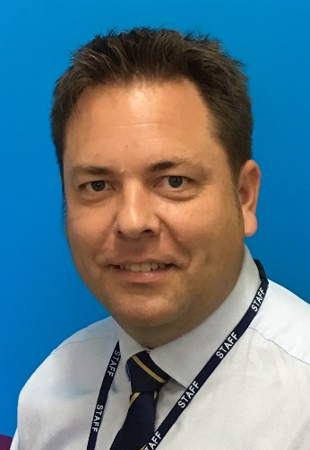
The week finished with a School Governance Committee (SGC) meeting. It is super to be working with a really enthusiastic and knowledgeable group who have volunteered to support and challenge the development of the school. We are in the middle of electing new governors; so please ensure you read about the candidates on the voting forms that were sent home earlier in week and cast your vote!
Have a wonderful weekend.
Ben Turner
Headmaster

