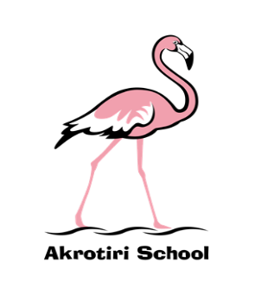
Akrotiri School
Friday Feeling #7
Friday 18 October 2019
He who shall not be named – our special guest from the BBC – gave us the most wonderful start to the week. The Flamboyant Flamingo Flurry couldn’t have been better (apart from an aerial shot of the long pink procession) and the costumes were tremendous. Thank you so much for investing in the occasion and for joining us on our pink ramble around the camp. As a result of your efforts we raised an impressive 737 Euros of loose change. Look out for us all on the TV spectacular on 16th November!
Hail Y6 – for your incredible Ancient Greece day. Your costumes (well done parents!) enhanced the occasion beyond belief and I thoroughly enjoyed (as did Mrs Henry) the treats that you prepared. Thank you and well done! Have a wonderful weekend.
It was great to catch up with all of the ‘Golden Mention’ children this week. I hosted a bumper edition for all of those who missed it earlier in the term and we had an excellent opportunity to celebrate and talk about aspects of school that they liked and things that they thought we could do better with – clearly the ball court needs attention.
And, for those still engaged with the World Cup, have a great weekend.
Ben Turner
Headmaster

