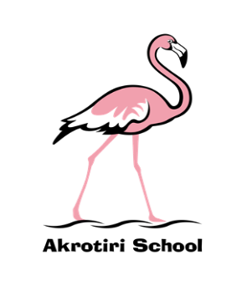
Friday 25 October 2019
Akrotiri School
Friday Feeling #8
In the final week of a long and busy half term, as a staff and with our wider family of MoD schools from across the island, we came together to work with Ross McGill, CEO and founder of Teacher Toolkit (www.teachertoolkit.co.uk). During two twilight sessions Ross challenged our thinking, gave examples of excellent practice from his most recent research and presented an extremely robust model of development which will fit into our direction of travel; an incredibly inspiring couple of sessions.
Equally inspiring has been the number of Y1 and Y2 parents who have been into school to work with their children. I saw amazing models being created in Y1 by parents and children and in Y2 I was able to join the sampling of some super baking and enjoyable crafting. Thank you to parents for coming in to support our learning and the staff for continuing to plan and deliver such great learning opportunities.
Hannah Robinson has been another visitor to the school this week. She has taken on the role of Teaching and Learning Consultant based at the MoD Schools HQ on Episkopi Garrison. Hannah has been able to work with all of our classes across the school and has been impressed with the learning and lessons in which she has been involved. We look forward to working with her more in the future to support our ongoing development.
Completing the week, we had three Halloween parties at the bowling alley. The PTA did a tremendous job decorating and organising the games and activities which were enjoyed by all of the children. Of course, the night would not have been what it was without a carefully selected musical soundtrack provided by the legendary DJ Mark (Humf) Humphries! Each set finishing with the iconic ‘Ghostbusters Theme’ which pulsated through our bodies; signalling the end of the ghoulish party which was then matched by the ghoulish weather outside! Thanks to all involved.
A special guest delivered the half term hero certificates today in the form of a penguin – well, Mrs Henry dressed as a penguin to be more accurate. Not a new fad, but symbolic of her imminent move to become Headteacher of Mount Pleasant MoD School, Falkland Islands. Mrs Henry will remain with us for a couple of days after half term before beginning the 13,000km journey to the South Atlantic with Zack and Summer. Watch out for a special ‘Falklands Feeling’ on 5 November.
And in other farewells (albeit temporary), we wish Sallyann Taylor the best of luck as she commences her maternity leave from today. We all hope the last few weeks of pregnancy go well and baby Taylor pops out with ease in December!
Finally, have a wonderful half term break, and enjoy the conclusion to what has been a very entertaining Rugby World Cup so far.
Ben Turner
Headmaster

