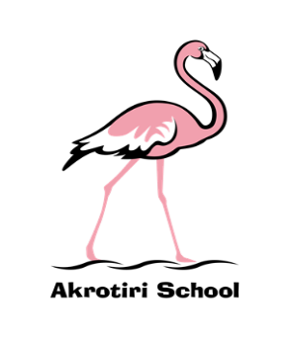
Akrotiri School
Falklands Feeling
Special Edition
Tuesday 5 November 2019
As the crow flies, 13166 km away in the South Atlantic, a small collection of islands awaits the arrival of three special people. Mrs Henry, Zack and Summer are about to embark on an epic journey and exciting next chapter of their lives. This comes as before the summer break, Mrs Henry was appointed to be the new Headteacher for Mount Pleasant School in the Falkland Islands. It is an extremely well-deserved promotion and one which she is absolutely ready for after nearly 18 months at the helm in Akrotiri School.
Mrs Henry completes her last day today, safe in the knowledge that she has ensured that Akrotiri School is in a great position. In difficult circumstances she has safeguarded opportunities for children and continued to develop staff. Mrs Henry has made my arrival at the school very smooth and engaged with me at every opportunity to make sure that I have a good overview of the current school position and has helped to shape the future direction.
In the short time that I have been here it is clear to see how well respected and how much confidence staff and children have in Mrs Henry. Her work rate is relentless and knowledge of the school phenomenal. Mrs Henry has a wonderful rapport with parents and visitors which has helped to strengthen the links with the community and secure the school’s reputation at the heart of the station.
Mount Pleasant School is receiving a first rate Headteacher and although we will be missing Mrs Henry, her legacy will live on.
Louise - we all wish you the very best for an exciting, fulfilling and professionally rewarding time in the Falkland Islands and can’t wait to hear all about it!
Very best wishes on behalf of the whole community,
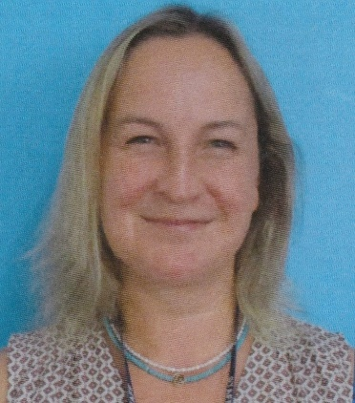
Louise Henry Ben Turner
Deputy Headteacher Headmaster

