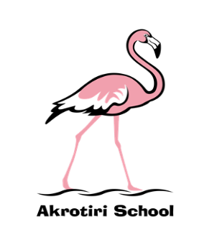
Akrotiri School
Friday Feeling
#015

Friday 08 January

Happy New Year – in contrast to the doom and gloom that COVID continues to reap, we at school have had a super week back. Where some of our teachers have been in isolation, they have liaised with the covering teacher to do live teaching inputs and continue the learning from the previous term. Children have come back with a very positive attitude and I can already see the big jump in maturity that has been made across the school.

I have had a fantastic time in Y4 and Y3 this week, teaching PE and French, which gave a super insight to attitudes towards learning and the progress that can be made in short amounts of time. Merci!

Next week sees the launch of our new behaviour policy, linked to the houses. A specially recorded assembly will be shown to all classes on Monday and I look forward to seeing how quickly children start earning house points. The house points will count towards individual certificates and weekly collective house totals.

Finally, we are expecting an announcement from the RoC today, which could impact on how we deliver education over the next few weeks. As soon as I have had confirmation on what this will look like, I will send out messages via our communication channels – Seesaw/Facebook.

Have a wonderful weekend,

Ben Turner
Headmaster

